Task 7: Year 11: Investigation Ohmic – Non-Ohmic Circuits : Validation Test

Name: Mark __________________/14 (30% total mark)

*(For full marks clearly show working)*

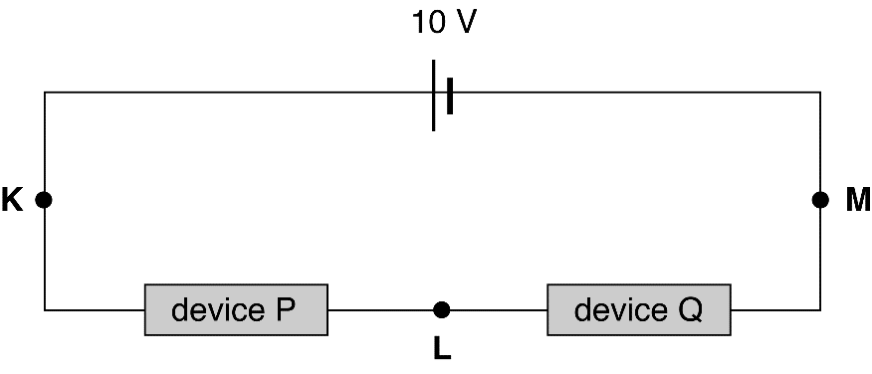Two electrical devices are connected in a series circuit as shown in the following diagram. The battery has zero internal resistance and the current at point K is 100 mA.

**a** Determine the current at point L and explain or show how you determined it? (2 marks)

The current–voltage characteristics for these two devices are shown in the graphs below.

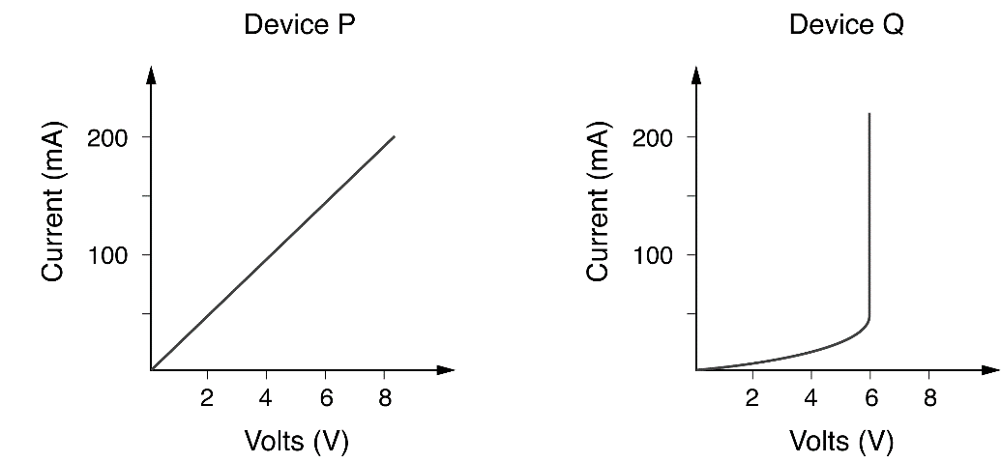

**b** Determine the potential difference between points K and L. (show working) (2 marks)

**c** Determine the potential difference between points L and M. (2 marks)

**d** Determine the effective resistance of device Q when I is 100 mA? (2 marks)

**e** State which of these two components obeys Ohm’s law and explain your reasoning? (2 mark)

**f** For the device you identified as ohmic , in part e, determine the gradient of the graph and use it to determine the resistance of the device in e. (4 marks)